BUDO JUNIOR SCHOOL
REMEDIAL WORK FOR TERM 1 2020 - SET TWO
MATHEMATICS FOR PRIMARY TWO

Name: _______________________________________________________________________________
Stream: ________________ Date: __________________________________________________
SECTION A

1. Draw a set of 4 cats;

2. Fill in the missing number.
78 , 79 , _______, 81, 82

3. Show Tens and Ones.
30 = ______tens ______ones.

4. Draw the beads on the abacus.
T O

2 3

5. Count in tens.
100, 110 , 120 , _____ , 140 , 150

6. Add correctly:
T O
4 6
+ 2 0__

7. Match number symbols with their number names.
12 two
2 twenty one
21 twelve

8. Arrange these numbers in ascending order. (Starting with the smallest)
7 , 5, 1 , 3 , 6 , 2 , 4

______________________________________________________________________
9. Subtract:
10 - 7 = _________ T O
6 2
- 2 2
__________________________
10. Shade the fractions;
2
4 = 1
3

11. How many tringles are in the diagram below?

There are __________________ triangles altogether.

12. Multiply:

2 x 3 = ____________

13. Circle the bigger number.
a) 2 0 6 or 26 (b) 16 or 61
14. Circle the correct word.
2 = twu , two , tuw

15. Write the fifth day of the week.
_____________________________________

16. Write the figure.
Fifty five = __________
______________________________________________________________________

SECTION B
17. Complete the puzzle below correctly.

4
3 1

2

2+

_____________________________________________________________________

18. Form new sets.
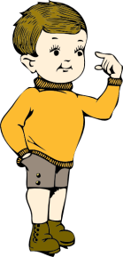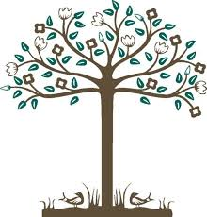
__________________

___________________

__________________

19. Tr. Mwasiti was given 9 cups. A goat came and broke 4 of them.
How many cups did Tr. Mwasiti remain with?

__________________________________________________________________
20. One sheep has four legs. How many legs do 5 sheep have?

___________________________________________________________________
21. Tell the time correctly:
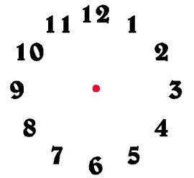 It is _______o’clock.
____________________________________________________________________

Work out:
22. 4 + 3 = 23. 1 + 1 + 1 =
10 10 12 12 12

___________________________________________________________________
24. Add the money.
Sh. 3 0 0
Sh. 2 0 0
_________________

25. Count in hundreds.
100, 200, ________, 400 , _______ , 600 , _______

26. Primary two boys were running to pick some apples from the basket.
Study the pictures below and answer questions that follow.

4th 3rd 2nd 1st
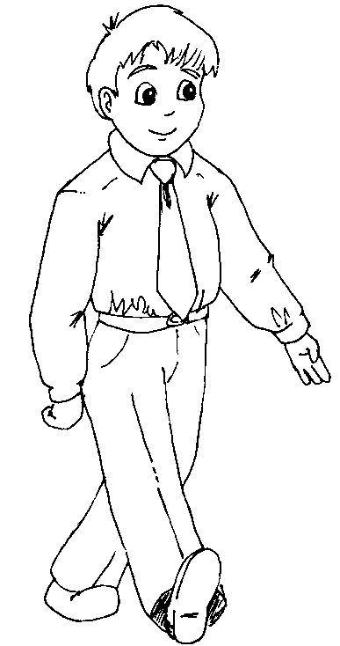
Sam Ali David Musa

a) Who was the first to pick the apples?
___________________________________________________________________
b) _______________was the last to pick the apples.
c) David was the ______________ to pick the apples.

27. Fill in the hundreds tens and ones.
a) 1 5 7 = ________hundreds ______tens _______ ones
b) _______ = 9 hundreds 3 tens 0 ones.
c) 2 hundreds 6 tens 3 ones = ___________

28. Mr. Masembe bought 70 hens. The headmaster gave him 20 more hens.
How many hens did he have altogether?

___________________________________________________________________
29. Tr. Robinah has sh. 500.
Tr. Barbrah has sh. 200.
How much money do they have altogether?

30. There are 3 legs on one stool. How many legs do 4 stools have?

___________________________________________________________________
31. How many sides does a triangle have?
A triangle has ____________sides.

___________________________________________________________________
32. Three boys from P.2 class collected the mangoes. Study the graph
and answer.
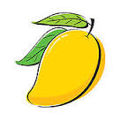
Lumu
Musoke
Kato
Questions:
a) Who collected the highest number of mangoes?
_______________________________________________________________
b) __________________ collected 4 mangoes.
c) How many mangoes did Musoke collect?
___________________________________________________________________
d) How many mangoes did the three boys collect altogether?

___________________________________________________________________

